FFF – Connectors

0. Set up the machine (Readme.txt)

Linux OS

0.1 Download Python 3.x

0.2 Setup the virtual environment in Linux

Windows 10

1. Run Script

1.1 run “main.py”

1.2 This program includes 4 scripts:

1. Hydraulic suitability
2. hydraulic suitability TS
3. ffc result metrics
4. performance metrics

1.2.1 Seclet “hydraulic suitability”

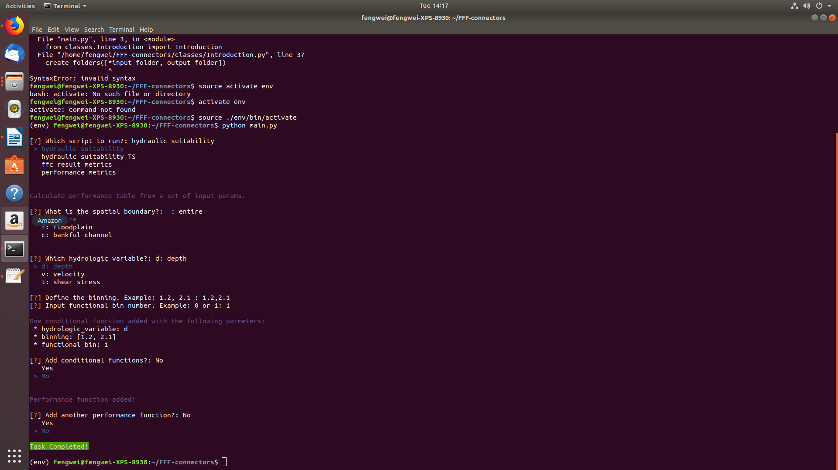

1.3 Choose a saptial boundary form the options:

1. entire: all area of the digital elevation map (EDM)
2. floodplain: floodplain and bankful channel
3. bankful channel only

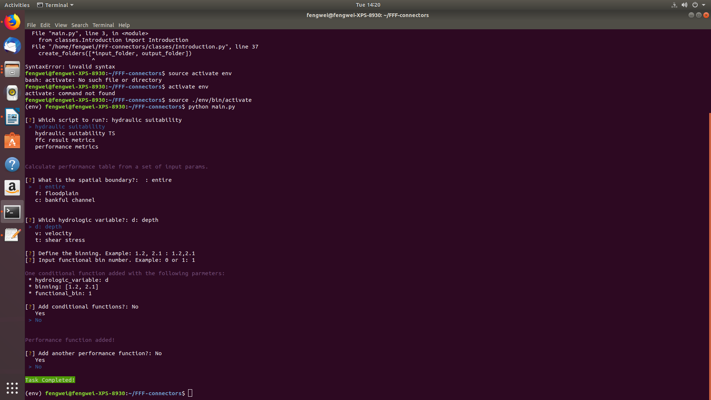

1.4 Define the bins. In this example, it means two bins: [0,1.2] and [1.2, 2.1]

1.5 Choose the functional bin. 0 means [0, 1.2] and 1 means [1.2, 2.1] in this example.

15.1 the screen shows a summary of the function: in this example, it says the depth (‘d’) between [1.2, 2.1] is a suitable habitat



1.6 You can add conditional function by selecting “yes” and specitying the condition: “all (AND)” or “any (OR)”.

1.6.1 Repeat 1.3 – 1.5

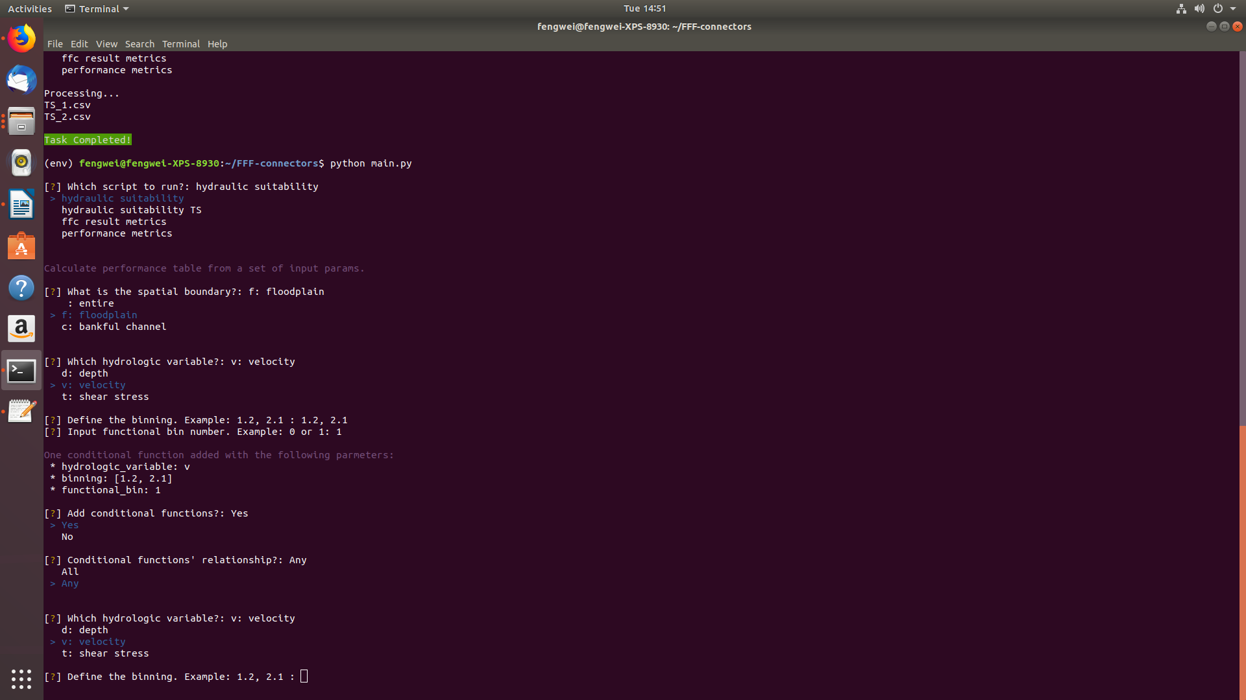

1.7 You can add another performance function by selecting ‘Yes’. If ‘No’ is selected, the screen will show “Task Completed!”



1.8 The result of this script can be found at “/FFF-connectors/files_output/hydraulic_suitability/performance_table.csv”

1.8.1 Open “performance_table.csv”. Each row represents the suitability value (between 0 and 1) of a channel type (e.g., T5 and T6) and a flow index (1 though 8 in this example; note the the index represent different levels of flow; the flow quantity is defined in the TUFLOW script)

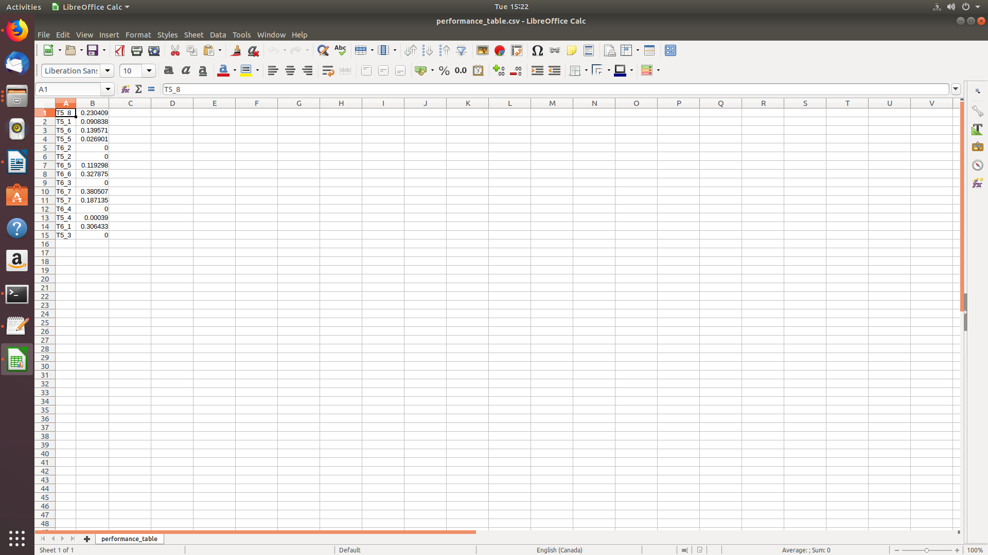

2.0 Hydraulic suitability TS

2.1 run “main.py”

2.2 Select “hydraulic suitability TS”

2.2.1 This script will us the create a “sutability curve” using the flow-and-suitability relationship derived from the “hydraulic suitability” script. The curve is a piece-wise linear function with x-axis of flow and y-axis of habitat suitability. TS_1.csv and TS_2.csv are both daily flow time seris data.

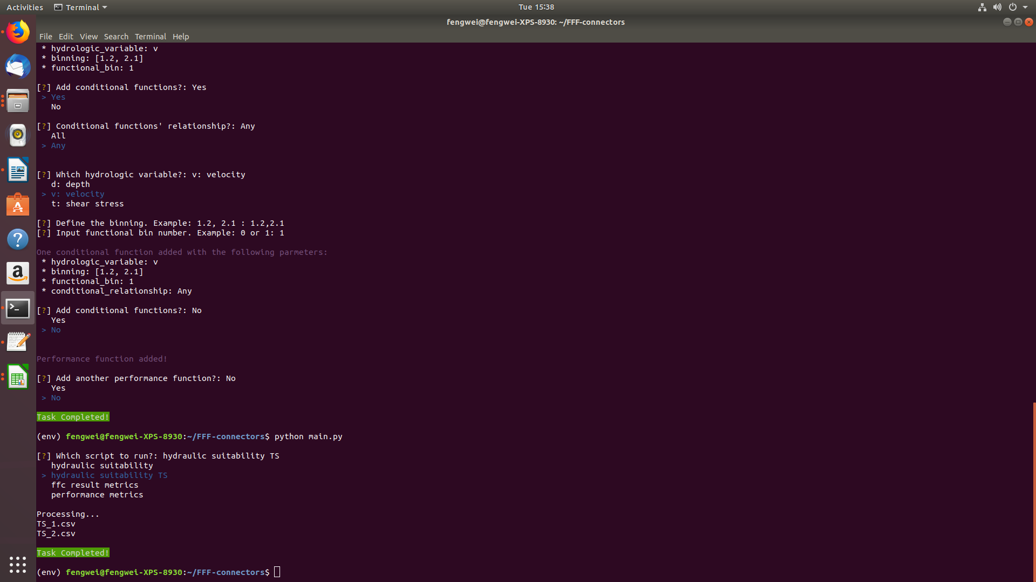

2.2.2 The results are the .csv stored in “/FFF-connectors/files_output/hydraulic_suitability”

2.2.3 Open T5_TS1. Each row shows a record of date, flow, and the the values of habitat suitability by function 1 and 2 (in this example we have define 2 habitat suitability functions)

